Kimble engine
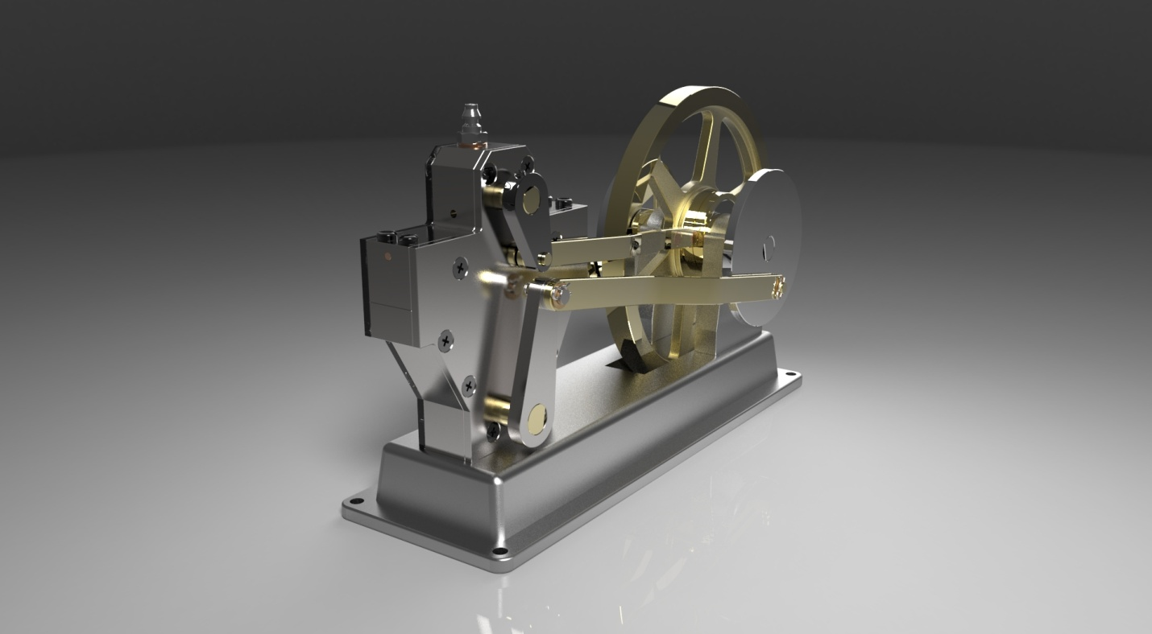
Abstract:
Kimble engine is small and simple engine. It is basically used in olden days. When compressed air enters through nozzle, a valve reciprocates to and fro connected to connecting rods which can revolve the fly wheel at speed. Which convert kinetic energy of compressed air into mechanical energy by using compressed air with capacity of one bar. it is very efficient engine, it takes very less power and gives greater power than intake. No toxic gases are released and it is less efficient.
The main objective of this project is design the model of fly wheel, connecting rods, cams etc., and model of Kimble engine in SOLID WORKS 2014.

